**Project Description:**

The Pay Slip Generation System (PSG System) is a C++-based application designed to automate the payroll management process for organizations. It efficiently handles employee data storage, salary calculations, and pay slip generation for two types of employees:

* Permanent Employees (with structured allowances & deductions)
* Contractual Employees (with fixed salary and tax deductions)

The system provides a menu-driven interface for administrators to:

* Add employee details
* Calculate salaries with appropriate allowances & deductions
* Generate formatted pay slips
* Manage overtime payments
* Configure tax rates and allowances

**Key Features Implemented**

1. **Professional Code Structure**:

* Proper class hierarchy with base Employee class
* Derived classes for PermanentEmployee and ContractualEmployee
* Separation of concerns with dedicated manager classes

1. **Complete Functionality**:

* Employee data management
* Salary calculations with all specified components
* Pay slip generation
* Overtime management
* System configuration

1. **Error Handling**:

* Input validation
* File operation error checking

1. **Professional Output Formatting**:

* Formatted pay slips
* Tabular overtime reports

1. **Data Persistence**:

* Binary file storage for employee records
* Separate storage for overtime records

1. **Configuration Management**:

* Global system configuration for rates and allowances

1. **User-Friendly Interface**:

* Clear menu system
* 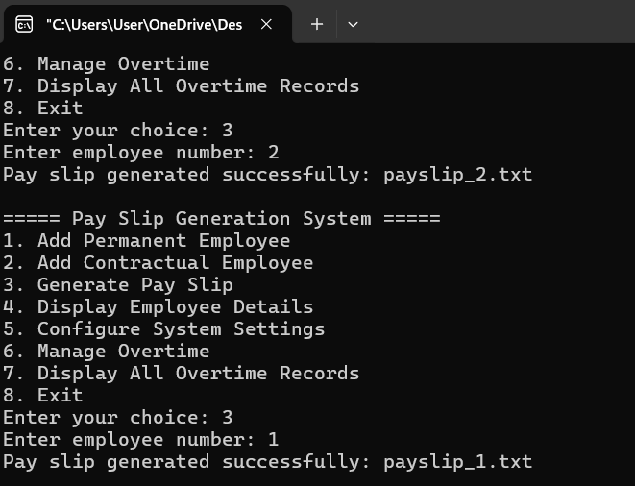Intuitive prompts

